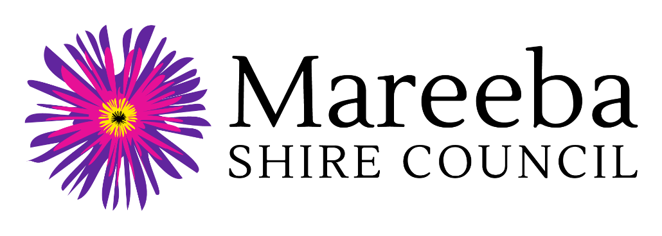

Regional Arts Development Fund
(RADF) 2023-24

Community Grant Outcome Report
(Public Projects and Activities)

Grant Recipient Name:
Project Name:
RADF Community Grant Amount Received:

Personal Information Collection Notice
Mareeba Shire Council is collecting your personal information for the purpose of assessing and processing of your Regional Arts Development Fund Community Grant Outcome Report. Information will be disclosed to Arts Queensland and where deemed necessary, may be used by Council to contact other agencies to verify their support of and / or involvement in the project. The information may additionally be used for reporting purposes and to support publicising and promoting the Regional Arts Development Fund. Your personal information will be handled in accordance with the provisions contained within the Information Privacy Act 2009 (Qld).

Human Rights Compatibility Statement
The Human Rights Act 2019 came into effect on 1 January 2020 and will mean fairer laws, policies and practices by public entities when dealing with the community on a day-to-day basis. Council holds an obligation under the Human Rights Act 2019 to make decisions and act in a way compatible with human rights. Council is committed to building a culture that respects and promotes human rights and we will give proper consideration to, and act compatibly with, human rights in our work and daily interaction with all persons.

Regional Arts Development Fund 2023-24
Community Grant Outcome Report
(Public Projects and Activities)

GENERAL INSTRUCTIONS
- This outcome report template is for those undertaking activities that have or will lead to a public outcome – e.g. exhibitions, events, engagement projects, creative developments, performances, place making projects, publications and public workshops.
- All RADF funding recipients are required to complete and submit this outcome report to Council within 8 weeks of their activity completion.
- Return your completed Outcome Report and supporting material to Senior Community Services Officer by one of the following methods:
  - Post: Mareeba Shire Council, PO Box 154, Mareeba Q 4880
  - In person: Mareeba Shire Council, 65 Rankin Street, Mareeba Q 4880
  - Email: info@msc.qld.gov.au

- ACTIVITY INFORMATION

Grant Recipient Name:
Contact Person Name:
Project Name:
Contact phone number:
Contact email:
Please provide a brief description of the project (max. 500 words)

- OUTCOMES

Please refer to the Data Dictionary at the end of this document for definitions of outcome measures and links to participant feedback surveys.

Outcome Measure – Project Statistics | Your Response
Number of attendees

Number of participants

Number of artists/ cultural workers employed

Number of people employed in other paid positions

Number of volunteers

Which sectors of the community made cash or in-kind contributions to the project? e.g. education, arts, health, business, tourism

Outcome Measure – Participant Feedback | Your Response
How did you collect feedback from participants / audiences?
Number of respondents providing feedback

Percentage of attendees or participants who rated the activity as good or excellent

What do you see as the top three outcomes from the activity? (max. 500 words)
Include any direct quotes from your participant / audience surveys that you wish to share (max 300 words)

Please outline how you acknowledged the RADF funding in project materials or activities.

- FINANCIAL STATEMENT
Please provide detailed information about all cash and in-kind contributions towards the project.

1. INCOME |  |  | 2. EXPENSES
1A. RADF Grant Requested |  |  | 2A. Salaries, Fees, Allowances
- RADF grant received | $ |  |  | $
 |  |  |  | $
 |  |  |  | $
 |  |  |  | $
1B. Cash Contributions from Applicant |  |  | 2B. Travel / Accomm / Venue Hire
 | $ |  |  | $
 | $ |  |  | $
 | $ |  |  | $
 | $ |  |  | $
1C. Cash Contributions from Other Sources (Sales, Fees, Grants, Donations) |  |  | 2C. Materials / Equipment & Other Project Costs
 | $ |  |  | $
 | $ |  |  | $
 | $ |  |  | $
 | $ |  |  | $
1D. In-Kind Contributions (Donations, Voluntary Labour, Discounts) |  |  | 2D. Administration / Insurance & Permits / Advertising
 | $ |  |  | $
 | $ |  |  | $
 | $ |  |  | $
 | $ |  |  | $
1E. TOTAL INCOME | $ |  | 2E. TOTAL EXPENSES | $

Please note that 1E. Total Income must equal 2E. Total Expenses

Please list which expenses were paid from the RADF grant.

Do you have any unspent RADF money?

If Yes - Please contact Senior Community Services Officer, Mareeba Shire Council, as soon as possible.

4. SUPPORT DOCUMENTATION

Please provide a small number of support documents that provide evidence that project or activity took place. This may include for example, online links, photos of the activity, program or promotional materials or copies of invoices or receipts. Documents or images may be imbedded into this Outcome Report, attached as separate files, or provided in hard copy. Please note that activity photos provided with your Outcome Report may be used by Arts Queensland or Mareeba Shire Council for the purposes of promoting the RADF program. Where relevant, please ensure you have obtained parental permission to share photographs which include children and young people.

5. DECLARATION

Declaration by funding recipient:
- I certify that the funding I received was used for the approved purposes and on the terms and conditions set out in the grant/funding agreement
- I certify that to the best of my knowledge, information detailed in this report is true and correct
- I understand I may be asked to provide the Council with additional information on the funded activity
- I understand that the Council and RADF Committee may share this outcome report with Arts Queensland as an example of good practice.

Signature  If you are under 18 years, your legal guardian must also sign this outcome report |  | Date: / /
Name in full
Position in group or organisation (if relevant)

APPENDIX: DATA DICTIONARY

Measure | Definition | Counting rules
Number of attendees | People who attend activities and events as audience members e.g. to see an exhibition, watch a performance, listen to a talk | - For ticketed activities, count each ticket holder as 1 attendee  - For non-ticketed activities, count each person as 1 attendee  - If people attend your activity primarily as audience members but they also have the opportunity to actively participate in an activity as part of their overall experience (e.g. at a festival), count them as attendees (not participants)  DO NOT COUNT:  - Television or radio audiences  - Publication readership  - People who are in the general vicinity of your activity but do not purposely attend (e.g. people who walk past a performance at a community market but do not stop for a substantial time to watch). If your activity is part of a broader event or festival you are not delivering yourself, you will need to conduct a head count of people who attend your specific activity.  - Participants as per definition below.  Resource:  - Counting Attendees Fact Sheet - http://www.arts.qld.gov.au/arts-acumen/resources/evaluation-and-reporting
Number of participants | People who actively participate in activities e.g. attend a class to make something, sing in a choir, participate in a training workshop | - Count each person participating in activities as 1 participant  - For single activities delivered over more than one day with the same group of people, only count each person as 1 participant (e.g. people participating in art classes delivered over a two-day weekend would be counted only once; people participating in weekly choir rehearsals would be counted only once)  - For different activities delivered as part of a series with the same group of people, count each person for each different activity that makes up the series (e.g. people participating in a series of three distinctly different workshops delivered as part of a series would be counted as 3 participants – once per workshop)  DO NOT COUNT:  - Staff  - Volunteers
Number of artists/cultural workers employed | People employed (on contract or permanent basis) as artists or arts and cultural workers over duration of project | - Count the number of individual staff receiving payment in an artistic or cultural role (irrespective of length of engagement) as part of the project delivery, including yourself as funding recipient if you were paid as an artist/arts and cultural worker  DO NOT COUNT:  - People who self-identify as artists/arts and cultural workers but were paid to undertake a non-arts role such as administration – they would be counted in as ‘other paid workers’ in the next question
Number of people employed in other paid positions | People employed over the direction of project (on contract or permanent basis) who were engaged in a role other than an artistic/cultural one | - Count the number of individual staff receiving payment in a non-artistic or non-cultural role (irrespective of length of engagement) as part of project delivery  DO NOT COUNT:  - People paid in an artistic or cultural role as reported in previous question  - External business providers who are not your staff members (e.g. caterers, equipment suppliers)
Number of volunteers | People engaged as volunteers to support delivery of your activities | - Count the number of individuals who volunteered to support delivery of your activities (irrespective of the amount of time they contributed) – note: volunteer work is unpaid (apart from reimbursement of out-of-pocket expenses); provided in the form of time, service or skills (donation of money or goods is not included); formal (carried out for or through an organisation or group)  - Count each individual once, irrespective of the number of different times they volunteer  DO NOT COUNT:  - Staff who contribute unpaid overtime
Types of sectors partnered with (if relevant) | If partnerships (financial or non-financial) developed to deliver your activities, types of sectors partnered with | - Note down the type of sector(s) you partnered with – e.g. arts, health, education, business, tourism etc.  DO NOT COUNT:  - Council’s RADF contribution as a partnership  - Other individuals or organisations funded by RADF for the same activity (i.e. your co-funding partner)
Percentage of attendees and participants who rated your activity as good or excellent | Percentage of survey respondents answering ‘good’ or ‘excellent’ to the question: Overall, how would you rate this activity? (response options: excellent, good, average, poor, very poor) | - Count the number of respondents to your survey who answer ‘good’ or ‘excellent’ to the overall rating question, and calculate it as a % of total survey respondents who answered this question  (EXAMPLE: At the end of your workshop you ask your 25 participants to complete a feedback survey. 20 people actually complete the survey and answer your overall rating question. Of those 20 people, 15 rate the workshop as ‘good’ or ‘excellent’. This would be calculated as 75% rating the activity as good or excellent).  Resources:  - Developing and Implementing Surveys Fact Sheet - http://www.arts.qld.gov.au/arts-acumen/resources/evaluation-and-reporting  - Sample surveys for different types of activities (these have been developed to support Arts Queensland funding recipients with completing their outcome reports, but can also be adapted for use by RADF funding recipients) - http://www.arts.qld.gov.au/arts-acumen/resources/evaluation-and-reporting/550-arts-queensland/5136-evaluation-tools
Number of survey respondents | The total number of survey responses received | - Count all respondents to your survey from the calculation above (NB: in the example provided above, the total number of survey respondents would be 20)

