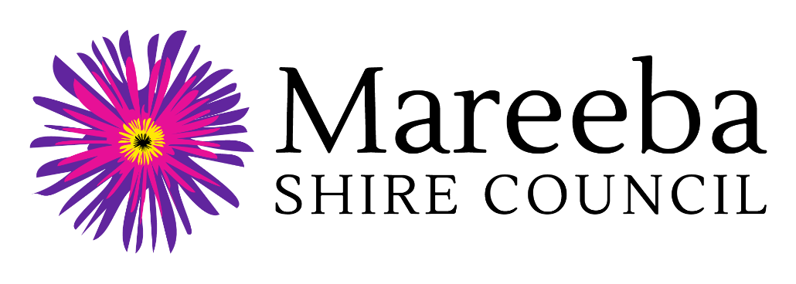

Regional Arts Development Fund
(RADF) 2022-23

Community Grant Outcome Report
(Non-Public and Professional Development Activities)

Grant Recipient Name:
Project Name:
RADF Community Grant Amount Received:

Personal Information Collection Notice
Mareeba Shire Council is collecting your personal information for the purpose of assessing and processing of your Regional Arts Development Fund Community Grant Outcome Report. Information will be disclosed to Arts Queensland and where deemed necessary, may be used by Council to contact other agencies to verify their support of and / or involvement in the project. The information may additionally be used for reporting purposes and to support publicising and promoting the Regional Arts Development Fund. Your personal information will be handled in accordance with the provisions contained within the Information Privacy Act 2009 (Qld).

Human Rights Compatibility Statement
The Human Rights Act 2019 came into effect on 1 January 2020 and will mean fairer laws, policies and practices by public entities when dealing with the community on a day-to-day basis. Council holds an obligation under the Human Rights Act 2019 to make decisions and act in a way compatible with human rights. Council is committed to building a culture that respects and promotes human rights and we will give proper consideration to, and act compatibly with, human rights in our work and daily interaction with all persons.

Regional Arts Development Fund 2022-23
Community Grant Outcome Report

(Non-Public and Professional Development Activities)

GENERAL INSTRUCTIONS
- This outcome report template is for that do not involve the general public and / or those undertaking professional / career development activities e.g. attendance at conferences and training workshops to develop your own skills, knowledge or career.
- All RADF funding recipients are required to complete and submit this outcome report to Council within 8 weeks of their activity completion.
- Return your completed Outcome Report and supporting material to Senior Community Services Officer by one of the following methods:
  - Post: Mareeba Shire Council, PO Box 154, Mareeba Q 4880
  - In person: Mareeba Shire Council, 65 Rankin Street, Mareeba Q 4880
  - Email: info@msc.qld.gov.au

- ACTIVITY INFORMATION

Grant Recipient Name:
Contact Person Name:
Project Name:
Contact phone number:
Contact email:
Please provide a brief description of the project (max. 500 words)

- OUTCOMES

Please rate the extent to which you agree or disagree with the following statements about the outcomes of your project or activity, using a scale: 1 strongly agree, 2 agree, 3 neutral, 4 disagree, 5 strongly disagree.

Outcome Statement | Rating  (1 strongly agree to 5 strongly disagree)
I developed new skills and knowledge.

I explored new directions in my practice.

It took my career to the next level of professionalism.

I developed new industry networks.

I developed new audiences or markets.

What do you see as the top three outcomes from the activity? (max. 500 words)
Do you have any other comments about your project or activity? (max. 300 words)

Please outline how you acknowledged the RADF funding in project materials or activities.

- FINANCIAL STATEMENT
Please provide detailed information about all cash and in-kind contributions towards the project.

1. INCOME |  |  | 2. EXPENSES
1A. RADF Grant Requested |  |  | 2A. Salaries, Fees, Allowances
- RADF grant received | $ |  |  | $
 |  |  |  | $
 |  |  |  | $
 |  |  |  | $
1B. Cash Contributions from Applicant |  |  | 2B. Travel / Accomm / Venue Hire
 | $ |  |  | $
 | $ |  |  | $
 | $ |  |  | $
 | $ |  |  | $
1C. Cash Contributions from Other Sources (Sales, Fees, Grants, Donations) |  |  | 2C. Materials / Equipment & Other Project Costs
 | $ |  |  | $
 | $ |  |  | $
 | $ |  |  | $
 | $ |  |  | $
1D. In-Kind Contributions (Donations, Voluntary Labour, Discounts) |  |  | 2D. Administration / Insurance & Permits / Advertising
 | $ |  |  | $
 | $ |  |  | $
 | $ |  |  | $
 | $ |  |  | $
1E. TOTAL INCOME | $ |  | 2E. TOTAL EXPENSES | $

Please note that 1E. Total Income must equal 2E. Total Expenses

Please list which expenses were paid from the RADF grant.

Do you have any unspent RADF money? Yes/No

If Yes - Please contact Senior Community Services Officer, Mareeba Shire Council, as soon as possible.

4. SUPPORT DOCUMENTATION

Please provide a small number of support documents that provide evidence that project or activity took place. This may include for example, online links, photos of the activity, program or promotional materials or copies of invoices or receipts. Documents or images may be imbedded into this Outcome Report, attached as separate files, or provided in hard copy. Please note that activity photos provided with your Outcome Report may be used by Arts Queensland or Mareeba Shire Council for the purposes of promoting the RADF program. Where relevant, please ensure you have obtained parental permission to share photographs which include children and young people.

5. DECLARATION

Declaration by funding recipient:
- I certify that the funding I received was used for the approved purposes and on the terms and conditions set out in the grant/funding agreement
- I certify that to the best of my knowledge, information detailed in this report is true and correct
- I understand I may be asked to provide the Council with additional information on the funded activity
- I understand that the Council and RADF Committee may share this outcome report with Arts Queensland as an example of good practice.

Signature  If you are under 18 years, your legal guardian must also sign this outcome report |  | Date:
Name in full
Position in group or organisation (if relevant)

